Name: ___________ Date: ____________

What are my triggers

Someone bothering me.

Work that is hard. Waking up early.

Someone correcting me. Seeing my best friend

Having to do something I do not want to do. Getting a present.

My brother or sister taking my stuff. Going to bed. Getting a bad grade.

Desert Going to school. Missing a fun activity. Going to the park with my friends

clean my bedroom. Homework. Someone making fun of me. Losing a game.

No one playing with me at recess. Not finishing my work on time. A teacher yelling at me.

___________________________ _______________________

_________________________________

__________________________

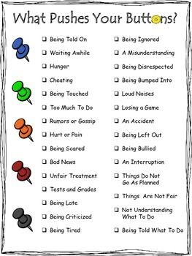
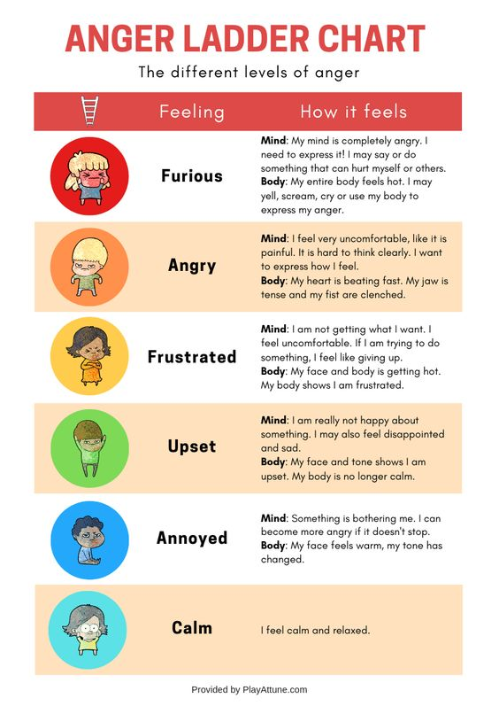

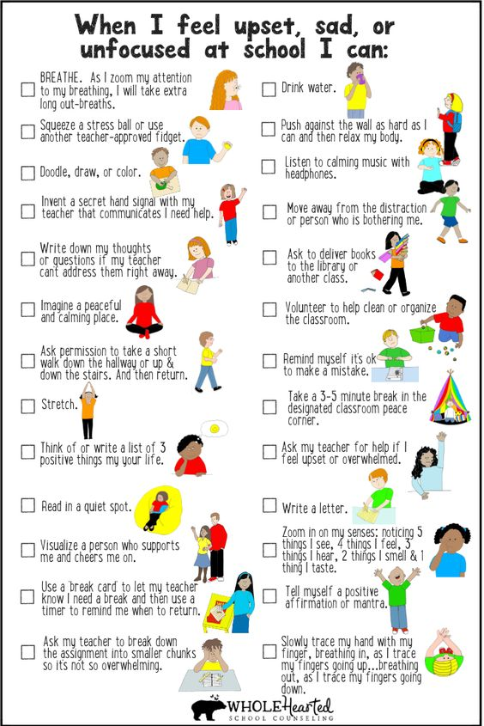

EXPECTED VS. UNEXPECTED BEHAVIORS

https://jeopardylabs.com/play/expected-vs-unexpected-behaviors

