Virtual Kids Club
Treatment plan

Theme: Zones of Regulation

Title: Emotional Regulation

Co-leaders: Melanie Vertentes and Inah Choi

Description: Age group: 8 to 12 years old.
Hello everyone! During our group session we will be using a coloring system from the Zones of Regulation program to first identify emotional behaviors in corresponds with each color (blue, green, yellow, and red). We will discuss as a group different behavioral situation when an individual has felt sad, happy, nervous, and mad. We will then discuss what color or zone the emotional behavior may fall under to help identify the behavior and allow the individuals to express how he or she felt when experiencing that emotion. Lastly, as a group, we will then discuss and write down different coping skills under each color or zone in order to help stay in the emotional state or improve emotional behavior.

Areas addressed: Emotional regulation, fine motor, executive function, social participation, and behavior self-regulation.

Materials needed: For this group, you will need to print out handouts provided and have a pen or pencil.
- Please print out or have the zones of regulation handout available during the group (the handout that provides example of emotions under each zone or color)

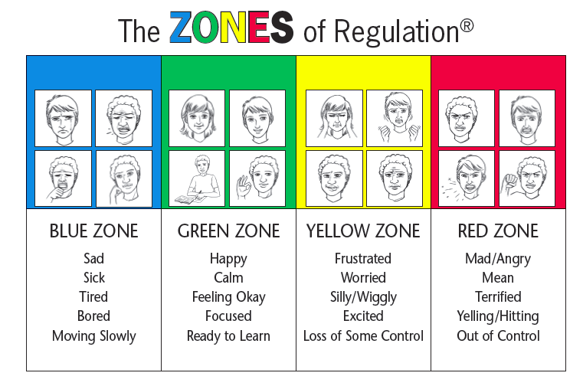
- Please print out the handout that allows the individuals to write their own strategy.
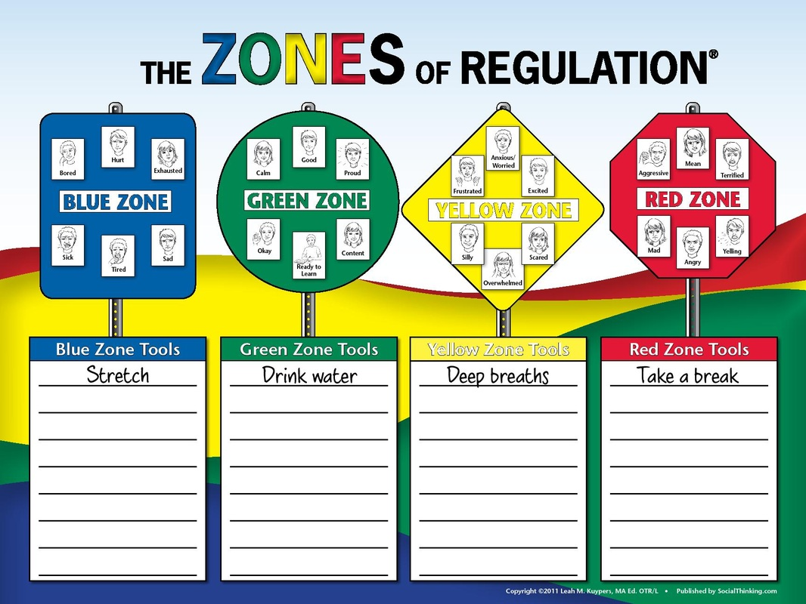

Marketing materials: photos, web links, handouts, printable takeaways
- Zones of regulation website: https://www.zonesofregulation.com/index.html

Evidence:
Eisenberg, N., Spinrad, T., & Eggum, N. (2010). Emotion-related self-regulation and its relation
to children's maladjustment. Annu Rev Clin Psychol, 6, 495-525. doi:10.1146/annurev.clinpsy.121208.131208.

