PUMPKIN WORKOUT
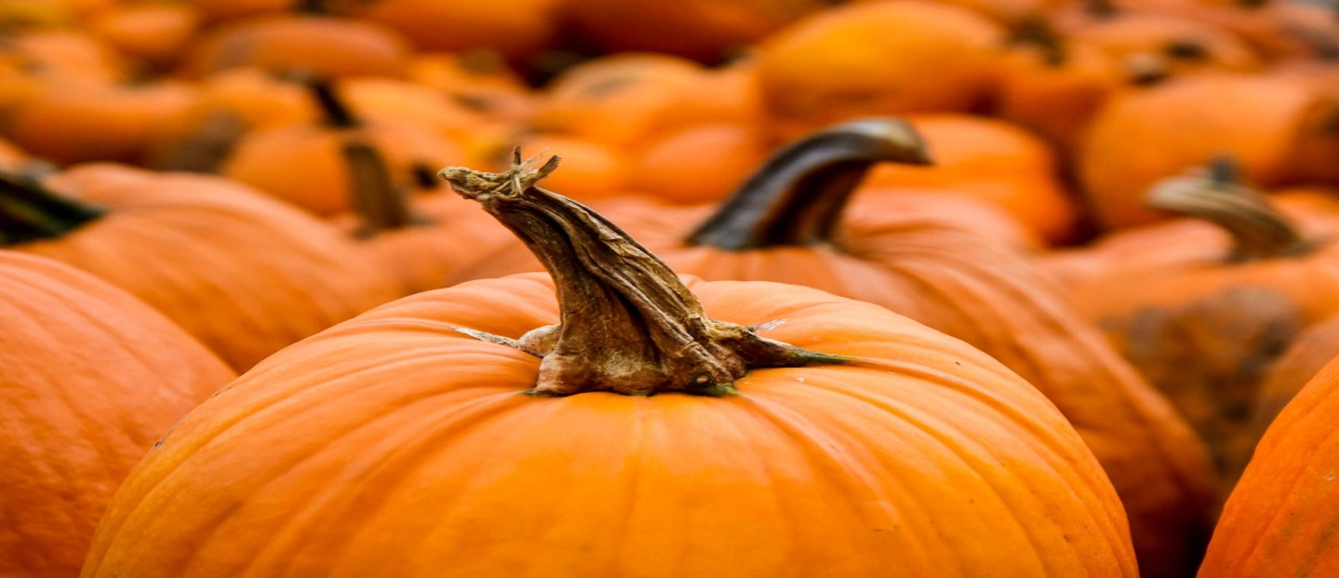

P is for pumpkin pose

U is for unicorn pose while repeating the alphabet

M is for marching in place for 20 seconds

P is for planks for 7 seconds

K is for kangaroo hop 10 times

I is for invent your own exercise

N is for nice job! Relax for 30 seconds

