“ The Bunny Hop Song” 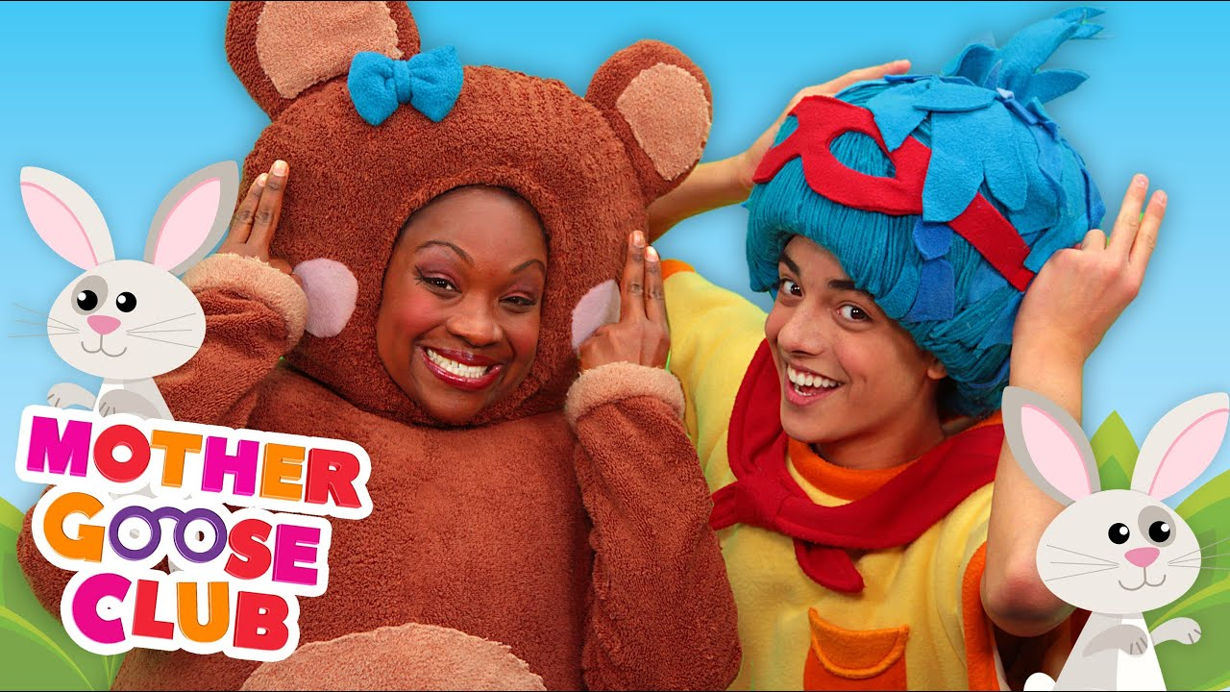
By: Mother Goose Club
Deep in the green wood animals play
Hopping and jumping the day away
Follow the animals in their game
Here we go now, let’s do the same
Hop hop hop like a bunny
Hop hop hop like a bunny
Hop hop hop like a bunny
Hop like a bunny, hop hop hop
Deep in the green wood animals play
Hopping and jumping the day away
Follow the animals in their game
Here we go now, let’s do the same
Jump jump jump like a joey
Jump jump jump like a joey
Jump jump jump like a joey
Jump like a joey, jump jump jump
Deep in the green wood animals play
Hopping and jumping the day away
Follow the animals in their game
Here we go now, let’s do the same
Leap leap leap like a froggy
Leap leap leap like a froggy
Leap leap leap like a froggy
Leap like a froggy, leap leap leap

