Emotions

Match to Same - Emotions
Directions: Cut on the dashed line. Match the pictures that are the same.

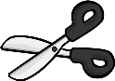
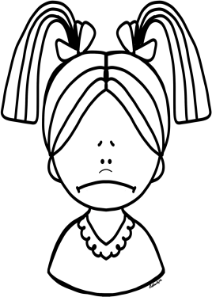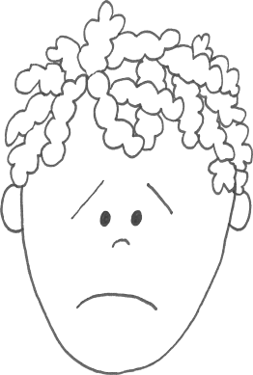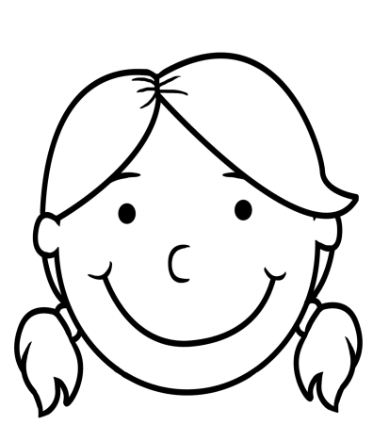Cut.
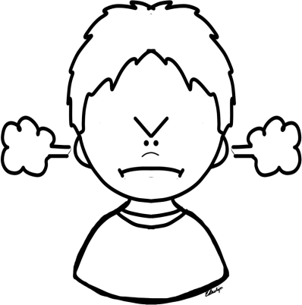
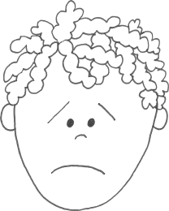

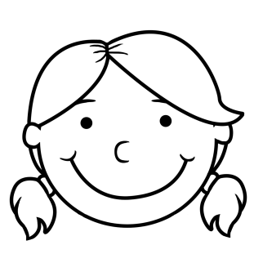
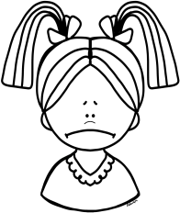
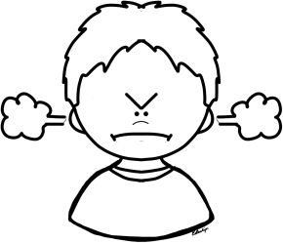

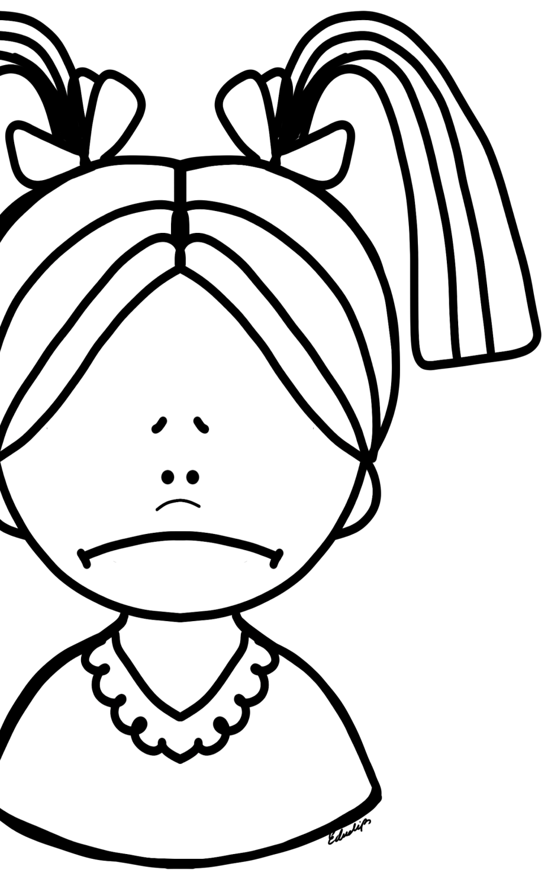Name

Sad

Directions:
Find the words below in the word search.

f | f | s | c | r | y
e | s | a | w | f | f
m | a | d | b | p | r
r | d | n | b | g | o
u | s | e | c | w | w
u | p | s | e | t | n
r | i | s | h | t | s

cry | sadness | mad
frown | upset | sad

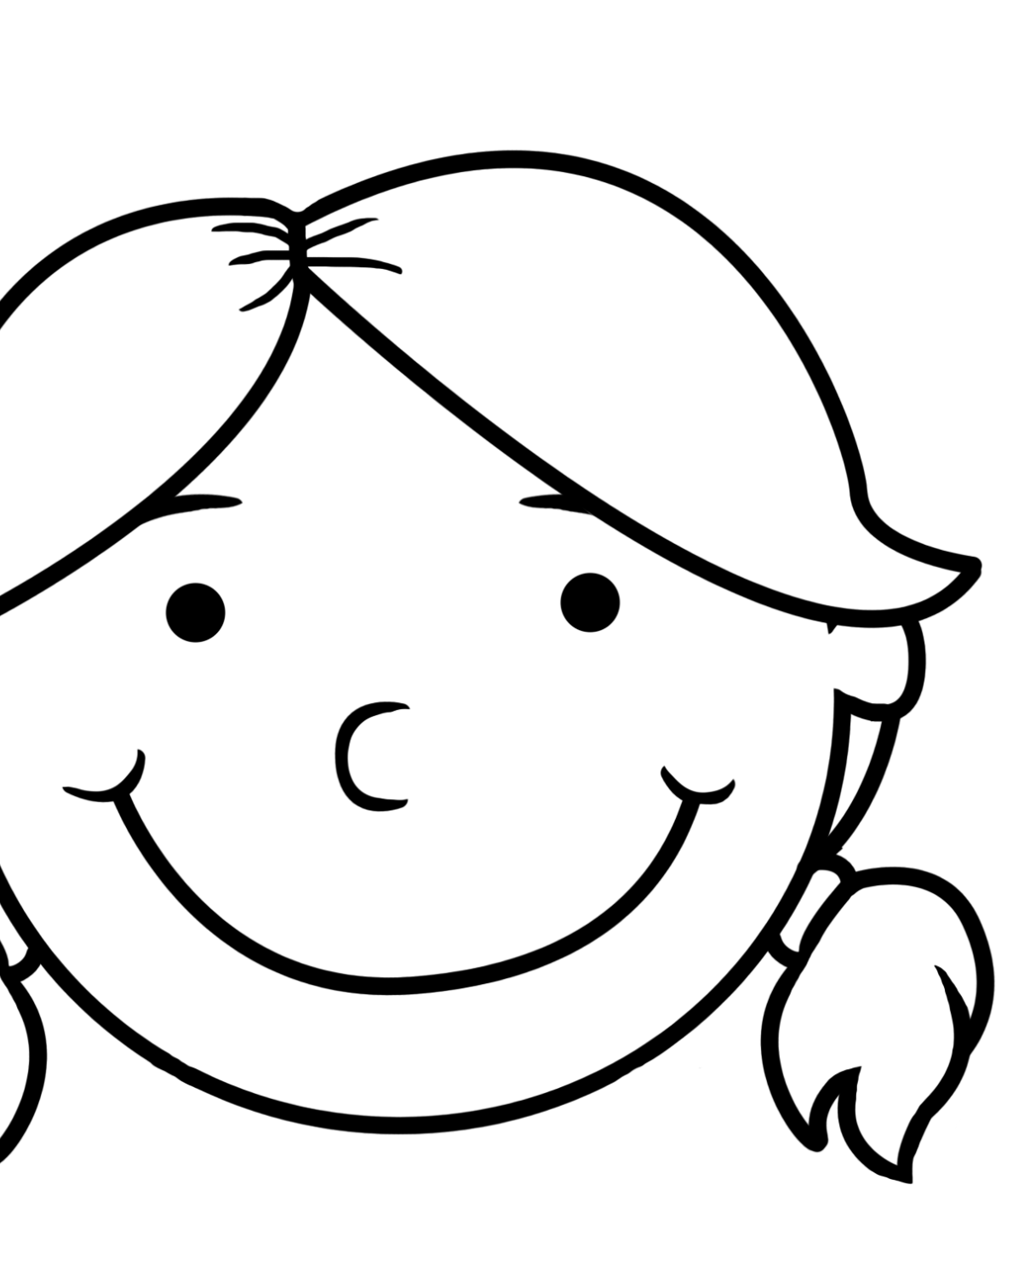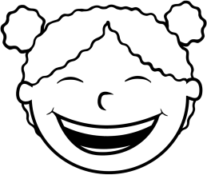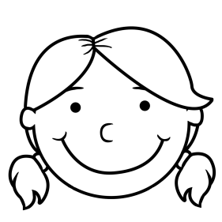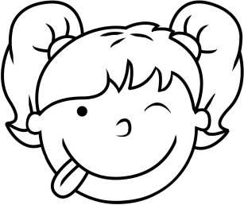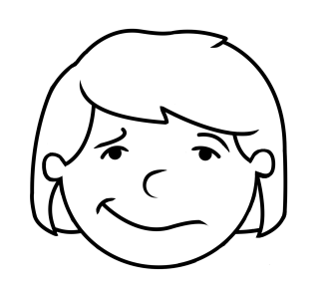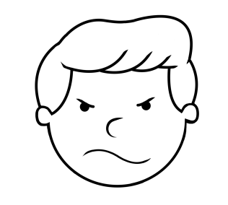Name

Happy
Directions: Circle the pictures that show a happy face.

Mark the word happy.
happy sad goat happy book happy pencil happy

Name
Scared
Directions: Draw a line to match the letters in the word scared.

s e
c d
a r
r a
e s
d c
Mark the word scared.  orange scared light | scared | beacon | scared | other | top
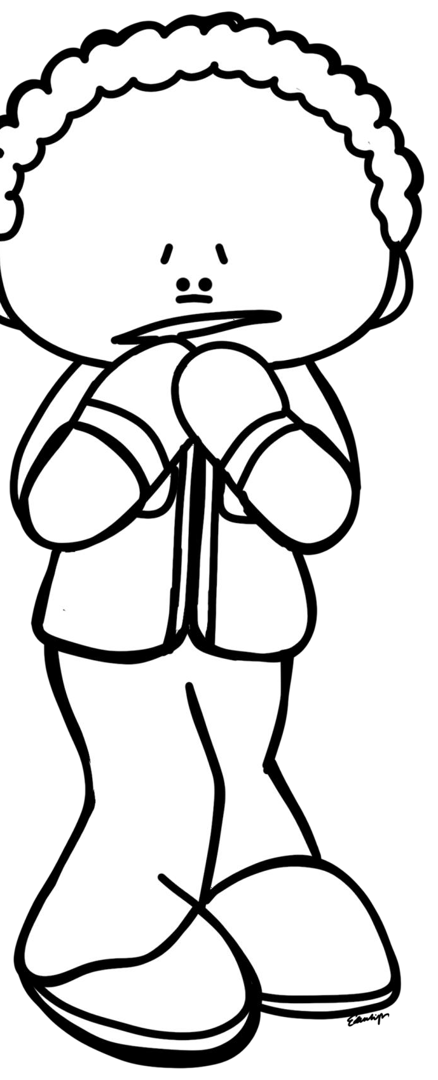

Name
Angry
angry
Definition:

Hostility or displeasure.
Directions: Circle the correct word that matches the definition.
 | danger | calm | angry
WRITE IT !!!
angry
Mark the word angry.
other angry blink angry angry red angry book
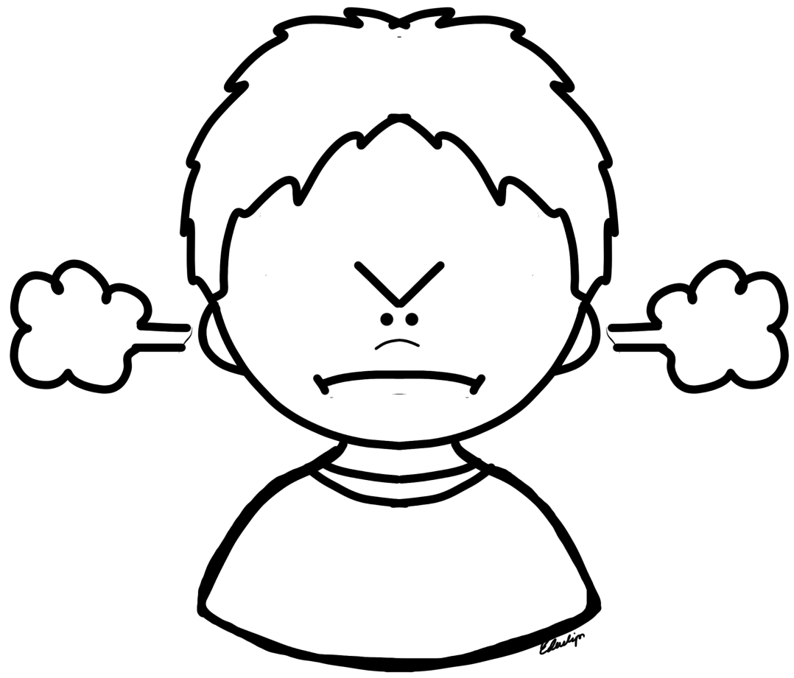
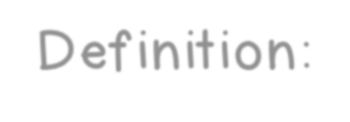

Point to the Emotion Cards
Point each emotion card. Match the word with the picture.

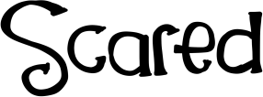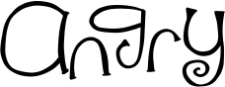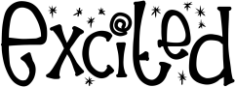

scared
shy angry excited

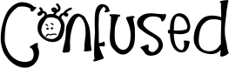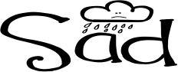

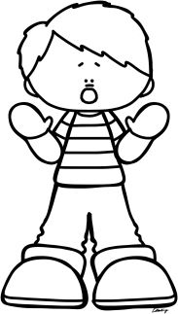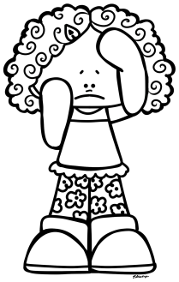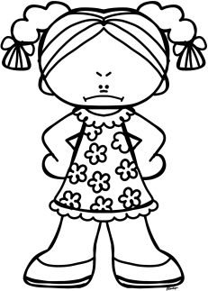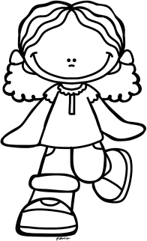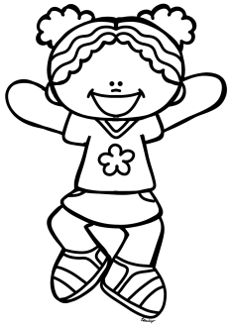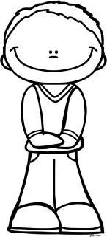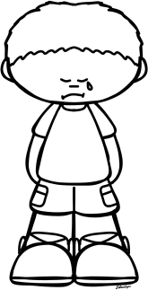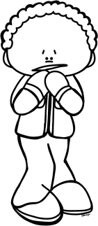confused
sad happy worried

